ISSS608 Visual Analytics and Applications
Timed Individual Assessment

DataVis Makeover is the process of redesigning existing data visualisation or dashboards to improve their clarity, effectiveness, and storytelling capacity. It focuses on applying best practices to make data easier to understand.

The Task
An online digital news agency is planning to publish a news article reporting the monthly trade balance of top ten markets of Singapore between 2018 to 2025 (i.e. pre-COVID, COVID, post-COVID, and Trump’s America First Trade Policy since January 20, 2025. Assuming the role of the chief graphic editor of the agency, you are task to:
- Evaluate the data visualisation provided by identifying its strengths and weaknesses.
- Sketch a redesigned visualisation that improves the clarity, effectiveness, and storytelling of the original.
- Create the redesigned visualisation (DataVis Makeover) using Tableau Desktop.
- Display four trade partners of Singapore with distinct trade balance trends and patterns reveal by the DataVis Makeover.
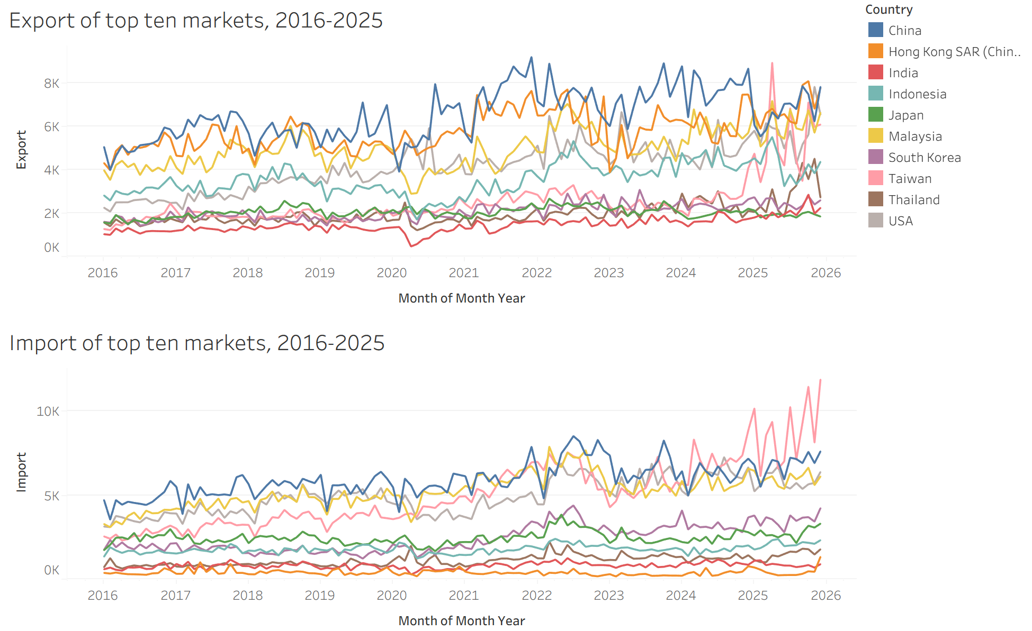

Submission Instructions
This is a timed individual assessment. You are required to complete the DataVis Makeover individually within 1 hour and 30 minutes during the class session.
- Write-up
You are required to submit a write-up in Microsoft Word format via eLearn. The write-up should include, but is not limited to, the following:
- At least three strengths of the original data visualisation.

- Informative and Accurate Title.
- Clear distinction of the 10 countries. Different colour coding were used to differentiate each countries.
- Relevant Data Presented. It presented the both trade figures (Export and Import) over the years.

- At least two weaknesses related to clarity and two related to aesthetic of the original data visualisation.

Clarity:
- The requirement is to present the monthly trade balance. Should present a chart showing the trade balance of each countries from 2018 to 2025. Should show the surplus and deficit clearly.
- Both charts y-axis are at different scale.
- Present years longer than required. 2016 to 2025 while the requirement was from 2018 to 2025.
Aesthetic:
- Too many colours used. Could have labelled the countries directly on respective lines.
- X-axis title wrongly labelled.

- A sketch of the redesigned visualisation, together with a brief explanation of how the redesign addresses the weaknesses identified in the original visualisation.
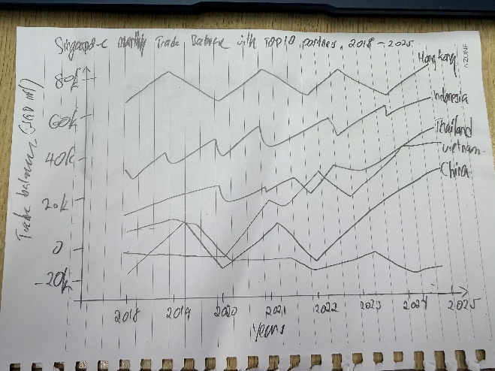
This sketch shows the Singapore’s Trade Balance (Export – Import) with the top 10 partners from 2018 to 2025. Four key partners (largest volume) are highlighted in colour (Hong Kong, Taiwan, USA and Malaysia), and the other six are greyed out. This reveals the trade balance on a line chart, labelled directly (remove the legend), from 2018 to 2025, presenting the trend visually.
- Four distinct trade balance trends and patterns of Singapore’s trade partners revealed by the DataVis Makeover.

- Hong Kong SAR (China): Persistently Dominant Surplus Line
- Taiwan: Deepening Deficit, Accelerating Downward
- USA: Volatile Crossing of the Zero Line
- Malaysia: V-Shaped Recovery from COVID Collapse

- Tableau Visualisation
Publish your DataVis Makeover on Tableau Public and submit the link via eLearn.

Assessment Rubic
Criteria | Excellent | Good | Satisfactory | Needs Improvement | Weights
Critique of Original Data Visualisation | Provides clear, insightful, and well-structured critique. Strengths and weaknesses are accurately identified and well justified using data visualisation principles. | Provides a logical critique with appropriate identification of strengths and weaknesses, with some supporting explanation. | Identifies some strengths and weaknesses but explanations are limited or partially unclear. | Limited or unclear critique. Strengths and weaknesses are poorly identified or unsupported. | 25%
Redesign Proposal (Sketch & Explanation) | Redesign sketch is clear and well thought out. Explanation clearly shows how the new design addresses the weaknesses and improves clarity and storytelling. | Redesign is reasonable and addresses most weaknesses. Explanation is generally clear. | Redesign addresses some weaknesses but explanation lacks clarity or completeness. | Redesign is unclear or does not meaningfully address the weaknesses identified. | 25%
Implementation Using Tableau Desktop | Tableau visualisation is well designed, clear, and visually effective. Appropriate chart types, layout, labels, and formatting are used. | Tableau visualisation is generally clear with appropriate chart type and layout, with minor issues. | Tableau visualisation is functional but contains several clarity or formatting issues. | Tableau visualisation is incomplete, difficult to interpret, or poorly implemented. | 35%
Bonus: Creativity & Storytelling | Demonstrates exceptional creativity, strong visual hierarchy, and compelling storytelling. | Shows good creativity and visual improvement over the original design. | Shows limited creativity but improves some aspects of the original visualisation. | Little or no improvement in creativity or storytelling. | 15%

